Assignment No:2

1. Even or Odd Number
Write a program to check whether a number is even or odd using if-else.
Example:
Input: 7
Output: Odd
Program:

package Javapac2;
import java.util.Scanner;
public class EvenOdd {

public static void main(String[] args) {

Scanner sc= new Scanner(System.in);
System.out.print("Enter a number:");
int num = sc.nextInt();

if(num%2==0)
{
System.out.println(num + " is even");
}
else
{
System.out.println(num + " is odd");

}

}
}

Output:

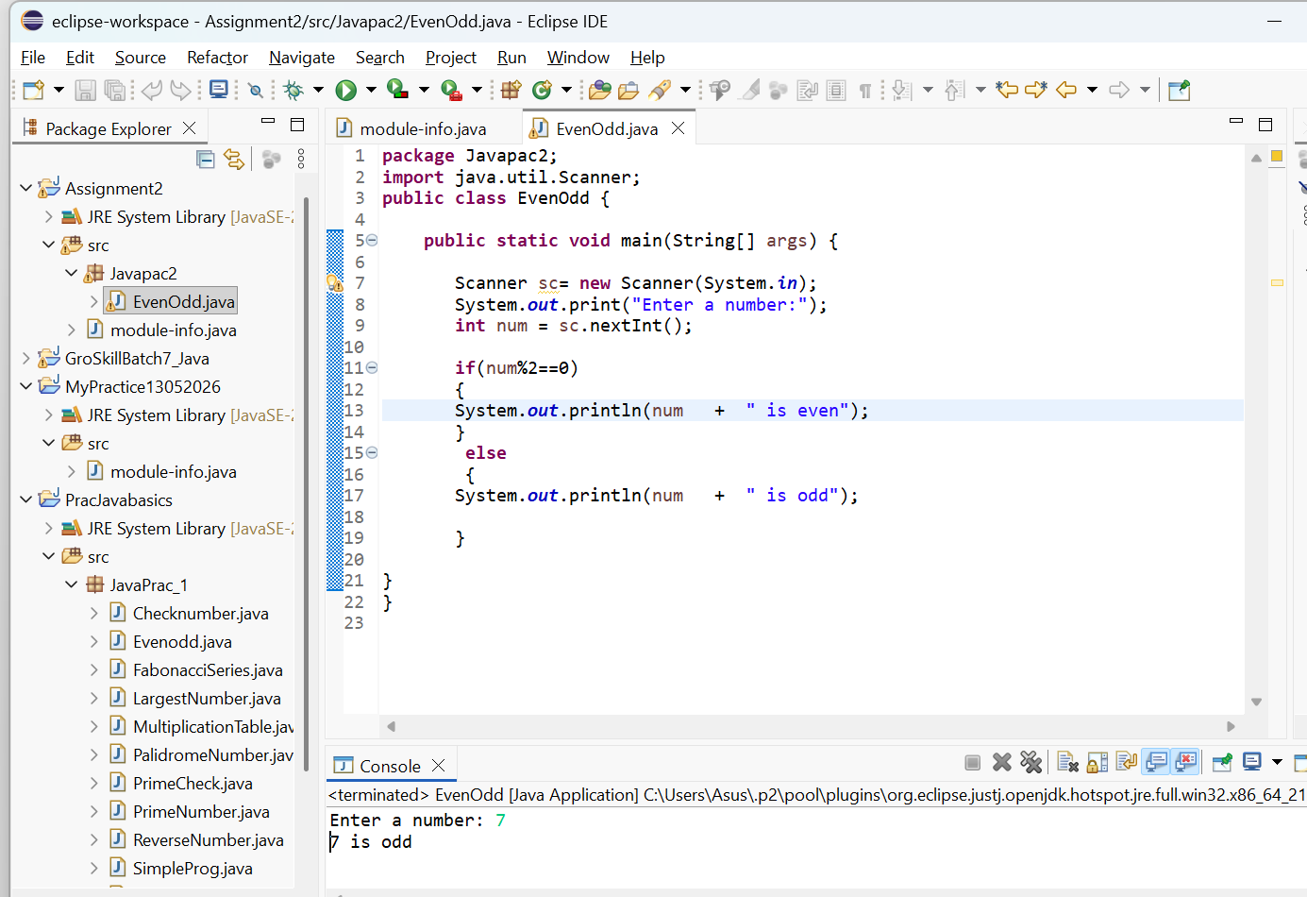
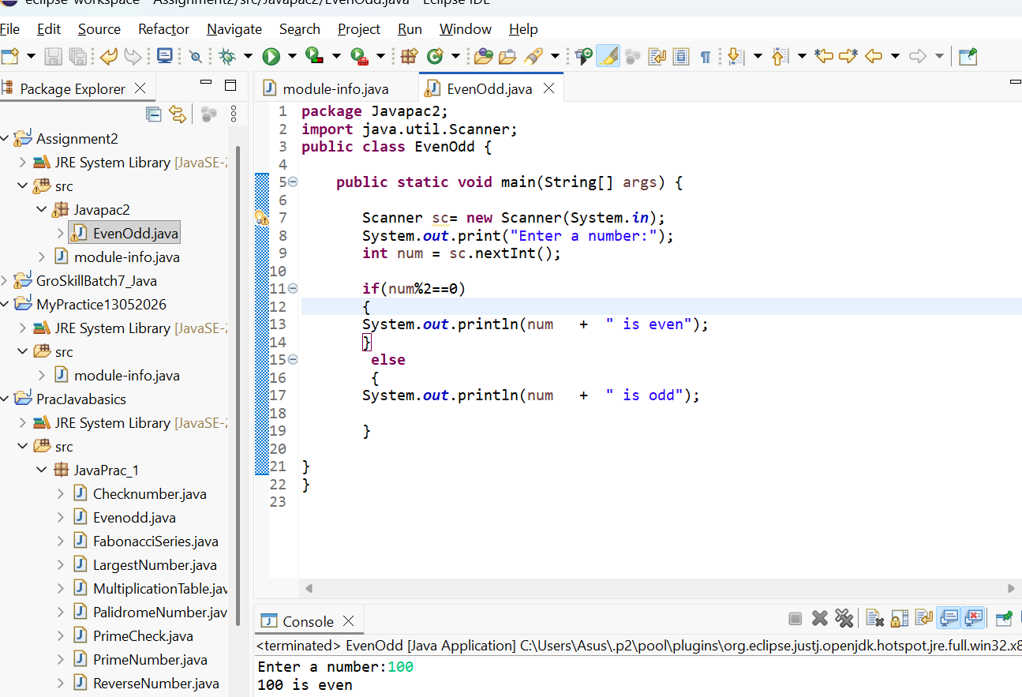

2. Largest of Three Numbers

Write a program to find the largest among three numbers using nested if-else.

Example:
Input: 10 25 15
Output: 25 is largest
Program
package Javapac2;
import java. util.Scanner;
public class LargestNumber {public static void main (String[] args)
{Scanner sc = new Scanner (System.in);
int a,b,c; System.out.print("Enter the 1st number:");
a = sc.nextInt(); System.out.print("Enter the 2nd number:");
b = sc.nextInt(); System.out.print("Enter the 3rd number:");
c = sc.nextInt(); if (a>b && a>c)
{ System.out.println(a + " is largest number"); }
else if (b>a && b>c) { System.out.println(b + " is largest number"); }
else {
System.out.println(c + " is largest number");
}
sc.close();
}
}
OutPut:
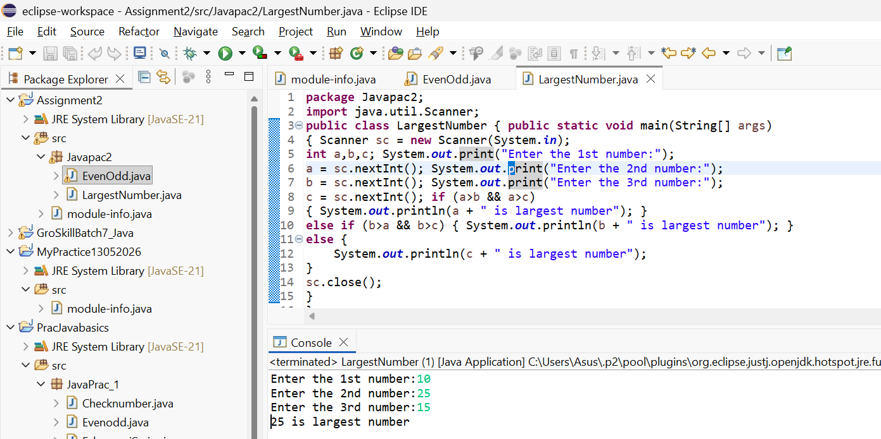
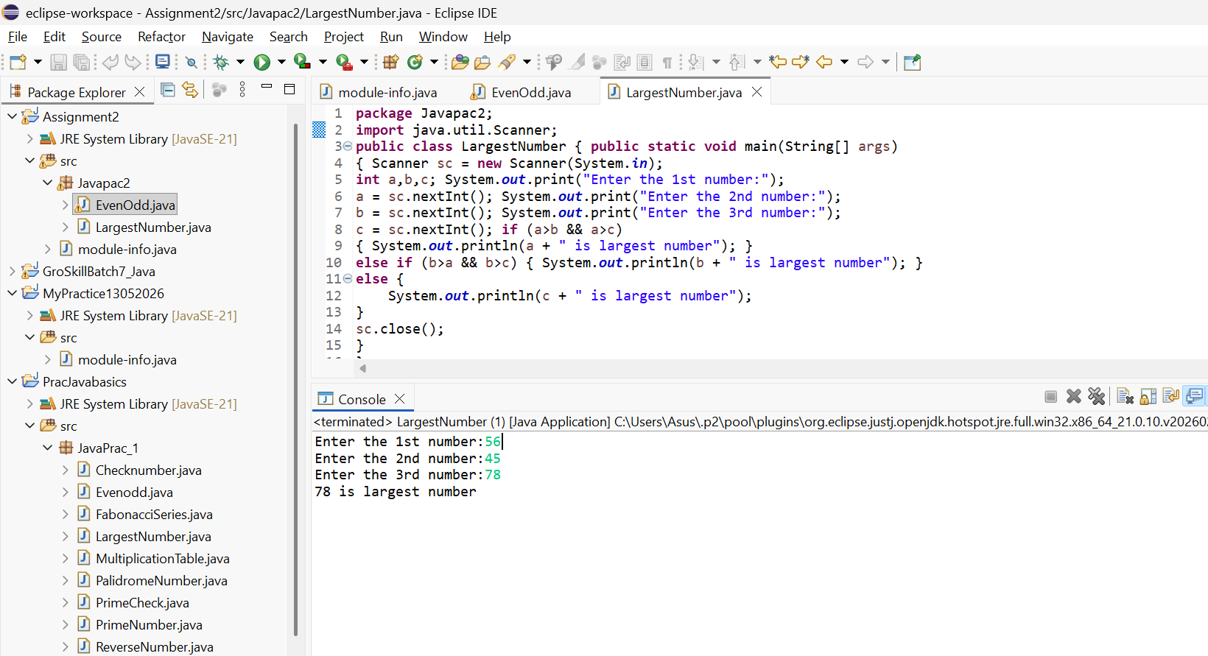

3. Leap Year Program
Write a program to check whether a year is a leap year or not.
Hint:
A leap year is divisible by 4 but not by 100 unless divisible by 400.

Program:
public class LeapYearCheck {
public static void main(String[] args) {
Scanner sc = new Scanner(System.in);
System.out.print("Enter a year: ");
int year = sc.nextInt();
if ((year % 4 == 0 && year % 100 != 0) || (year % 400 == 0)) {
System.out.println(year + " is a Leap Year.");
} else {
System.out.println(year + " is NOT a Leap Year.");
}
sc.close();
})
Output
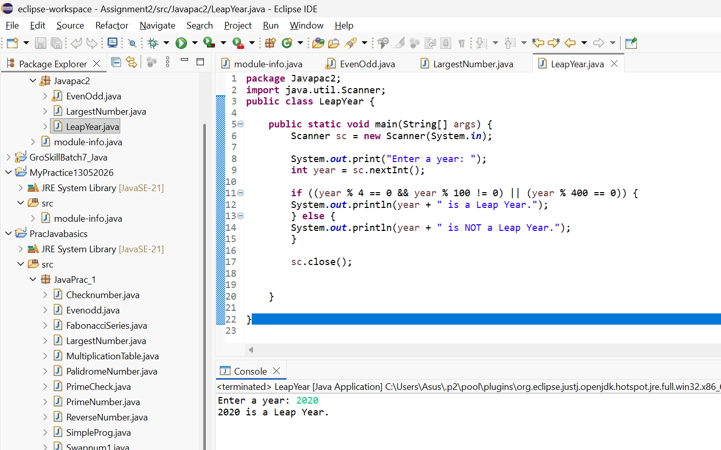

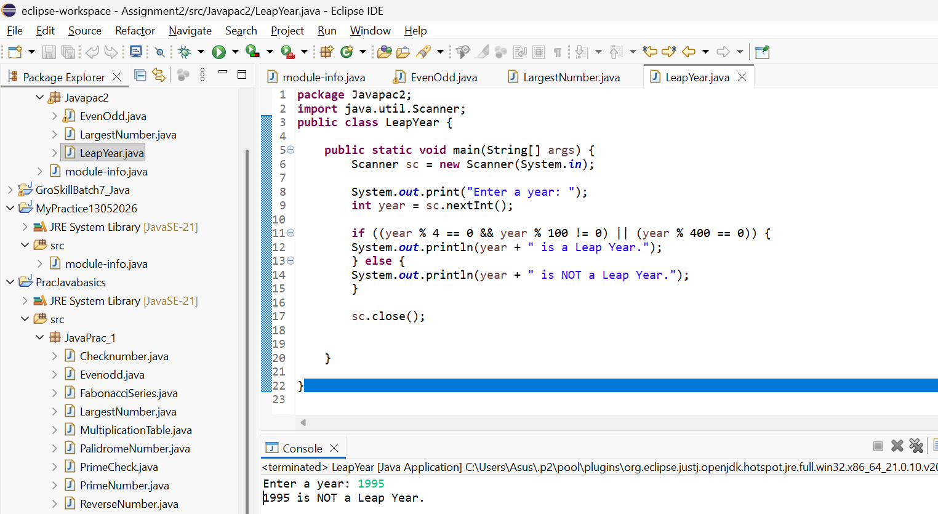

4. Positive, Negative, or Zero
Write a program to check whether a number is positive, negative, or zero.
Program:
package JavaPrac_1;
import java. util. Scanner;

public class Checknumber {
public static void main(String[] args) {

Scanner sc = new Scanner(System.in);

System.out.print("Enter a number: ");
int num = sc.nextInt();

if (num > 0) {
System.out.println("The number is Positive.");
} else if (num < 0) {
System.out.println("The number is Negative.");
} else {
System.out.println("The number is Zero.");
}

sc.close();
}
}

Output:
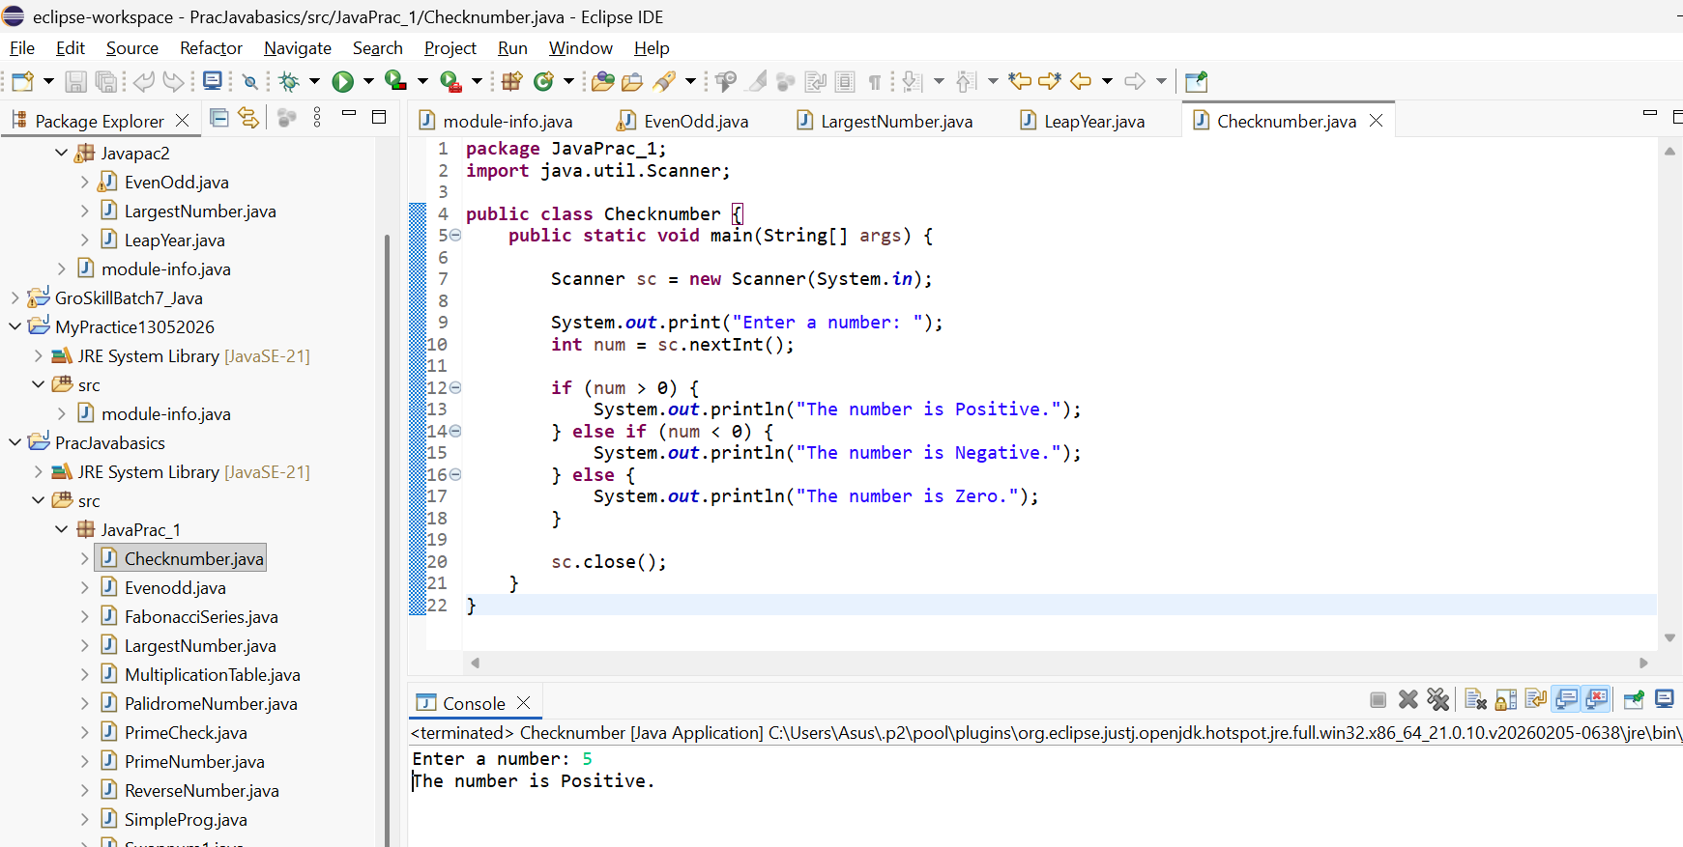

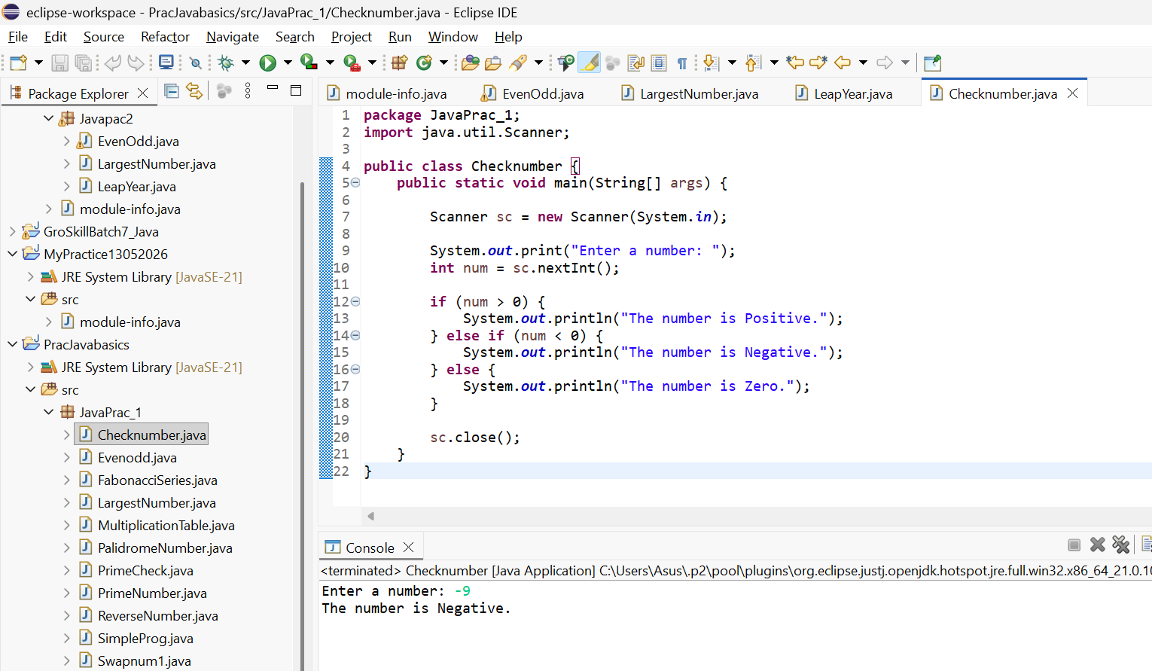
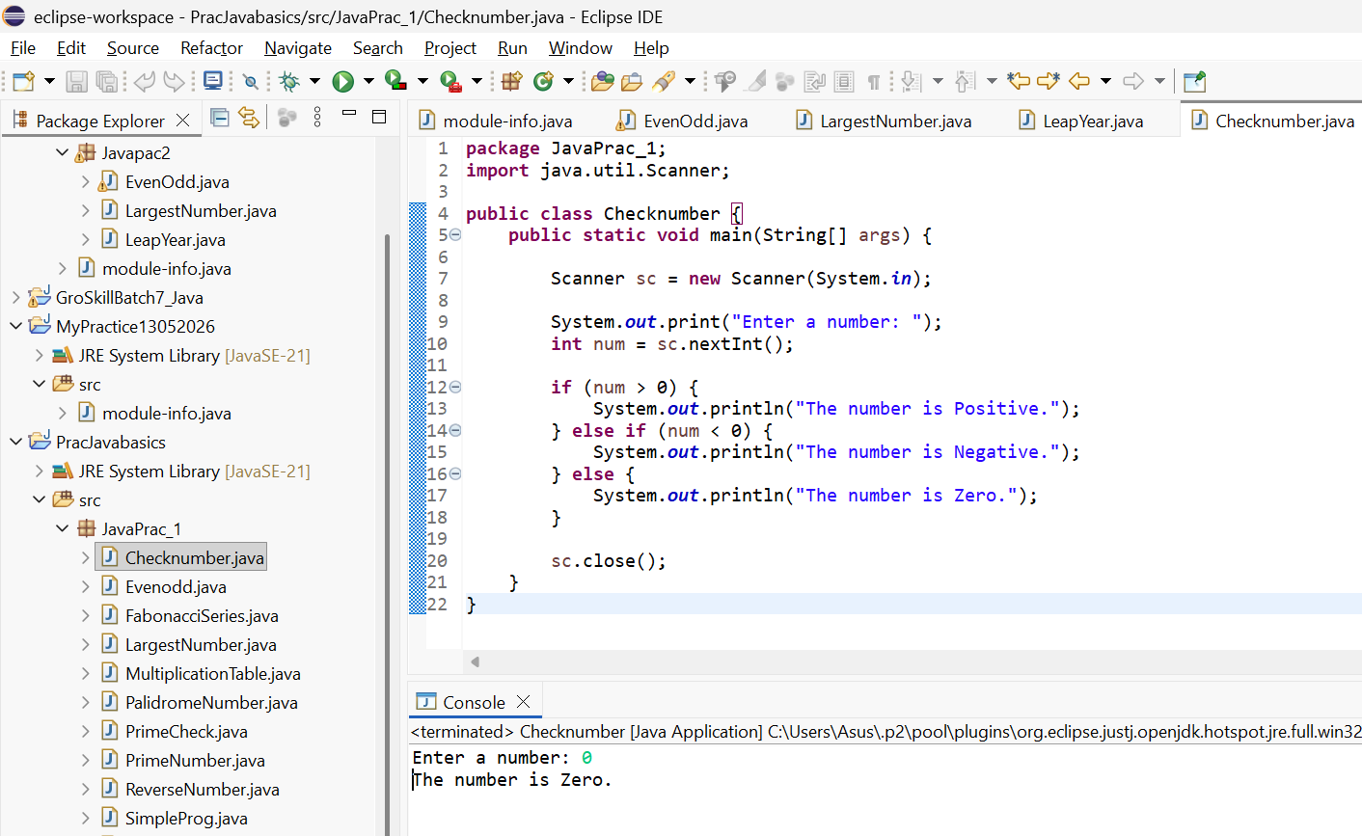

5. Print Numbers from 1 to N

Write a program using a for loop to print numbers from 1 to N.
Example:
Input: 5
Output: 1 2 3 4 5

Program:
package JavaPrac_1;
import java. util. Scanner;

public class Print Numbers
{
public static void main (String[] args)
{
Scanner sc = new Scanner(System.in);

System.out.println ("Enter the value of N");

int N = sc.nextInt();

for (int i = 1; i <= N; i++)
{
System.out.print(i + " ");
}

sc.close();
}
}
Output:
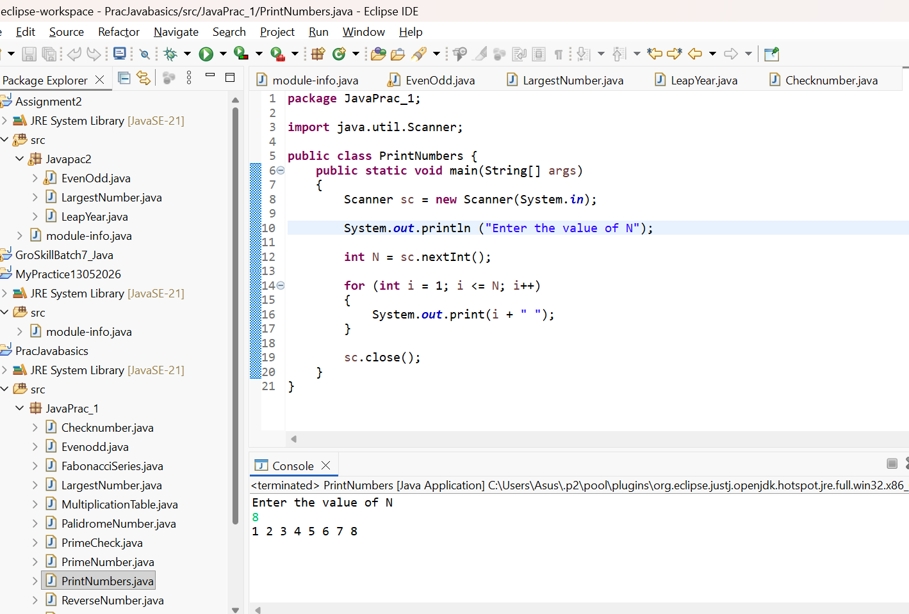

6. Sum of First N Natural Numbers

Write a program using a while loop to calculate the sum of first N natural numbers.
Example:
Input: 5
Output: 15
Program:

package Javapac2;
import java.util.Scanner;
public class SumofNaturalNumbers
{

public static void main(String[] args) {
System.out.println("Enter the value of N");

Scanner sc = new Scanner(System.in);

int n = sc.nextInt();
int sum = 0;
int i = 1;

while (i <= n) {
sum += i;
i++;
}

System.out.println(sum);

sc.close();
}
}

Output:
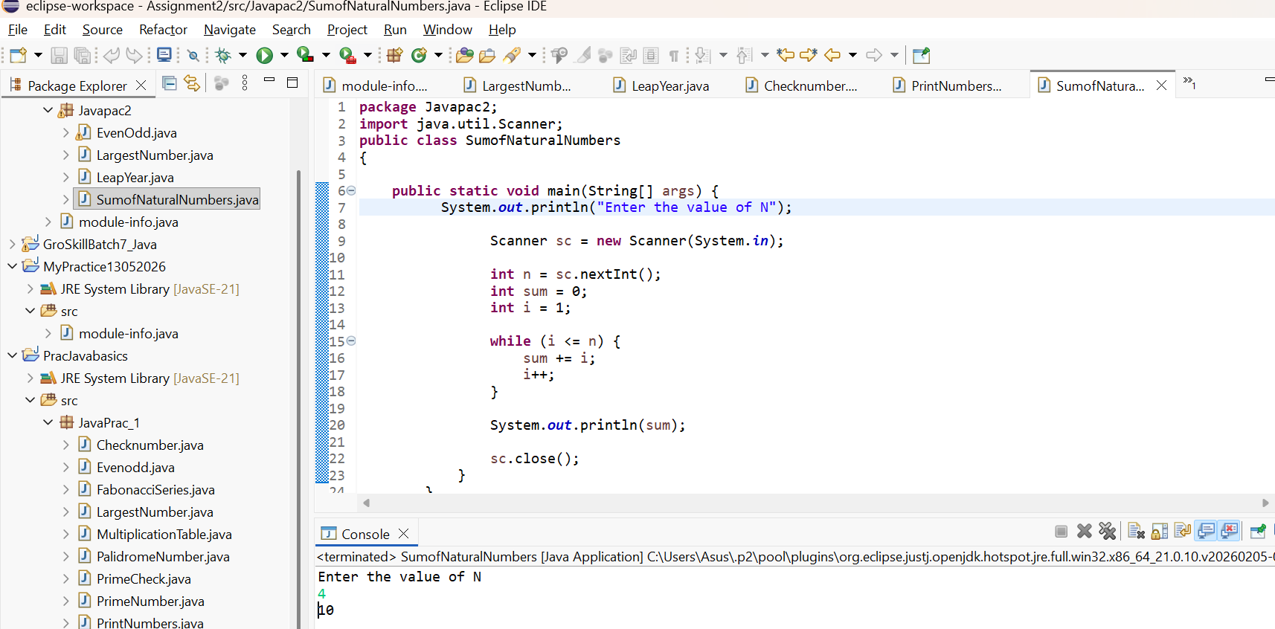
7. Multiplication Table

Write a program to print the multiplication table of a number using a for loop.

Example:
Input: 4
Output:
4 x 1 = 4
4 x 2 = 8
...4 x 10 = 40

Program:
package JavaPrac_1;
import java. util.Scanner;

public class MultiplicationTable {

public static void main(String[] args) {

Scanner sc = new Scanner(System.in);

System.out.print("Enter a number: ");
int num = sc.nextInt();

System.out.println("Multiplication Table of " + num);

for (int i = 1; i <= 10; i++){
System.out.println(num + " x " + i + " = " + (num * i));
}
sc.close();}}

Output:
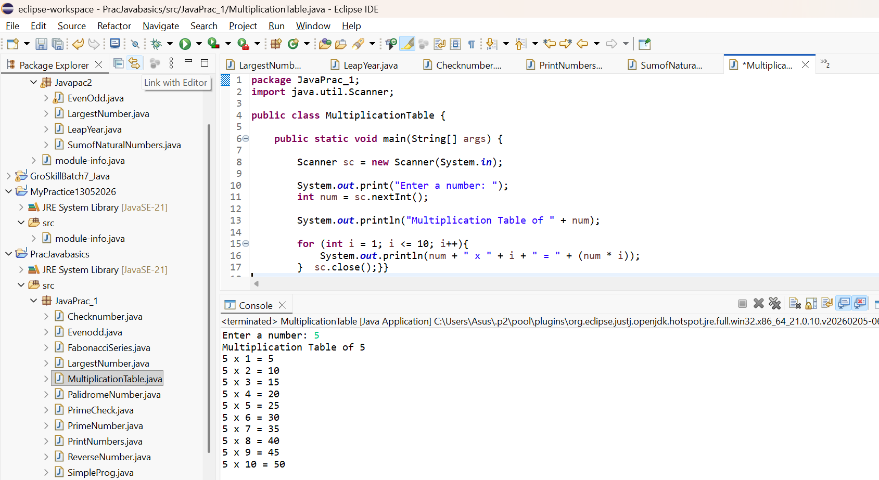
8. Reverse a Number
Write a program using a while loop to reverse a number.
Example:
Input: 1234
Output: 4321
Program:
public class Main {
public static void main(String[] args) {
Scanner sc = new Scanner(System.in);
int num = sc.nextInt();
int reverse = 0;
while (num != 0) {
int digit = num % 10;
reverse = reverse * 10 + digit;
num = num / 10;
}
System.out.println(reverse);
sc.close(); }}
Output:
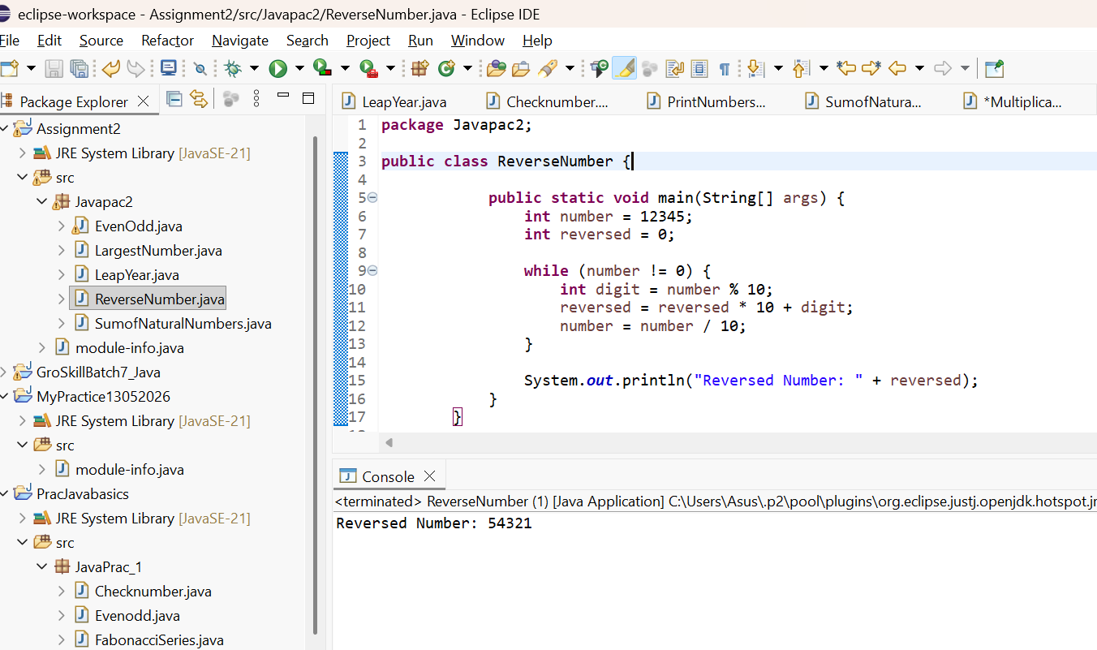

9. Palindrome Number
Write a program to check whether a number is palindrome or not.
Example:
Input: 121
Output: Palindrome
Program:
package JavaPrac_1;
import java.util.Scanner;
public class PalindromeNumber {
public static void main(String[] args) {
Scanner sc = new Scanner(System.in);
System.out.print("Enter a number: ");
int num = sc.nextInt();
int original = num;
int reverse = 0;

while (num != 0) {
int digit = num % 10;
reverse = reverse * 10 + digit;
num = num / 10;
}

if (original == reverse) {
System.out.println("Palindrome Number");
} else {
System.out.println("Not a Palindrome Number");
}

sc.close();}}
Output:
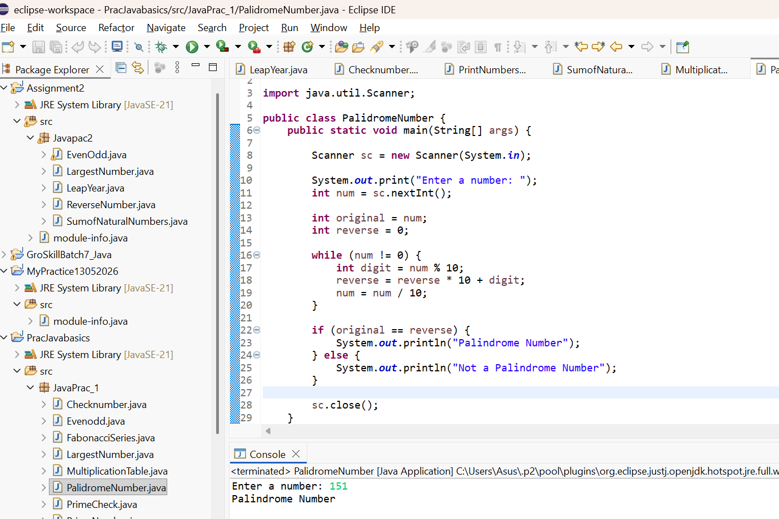

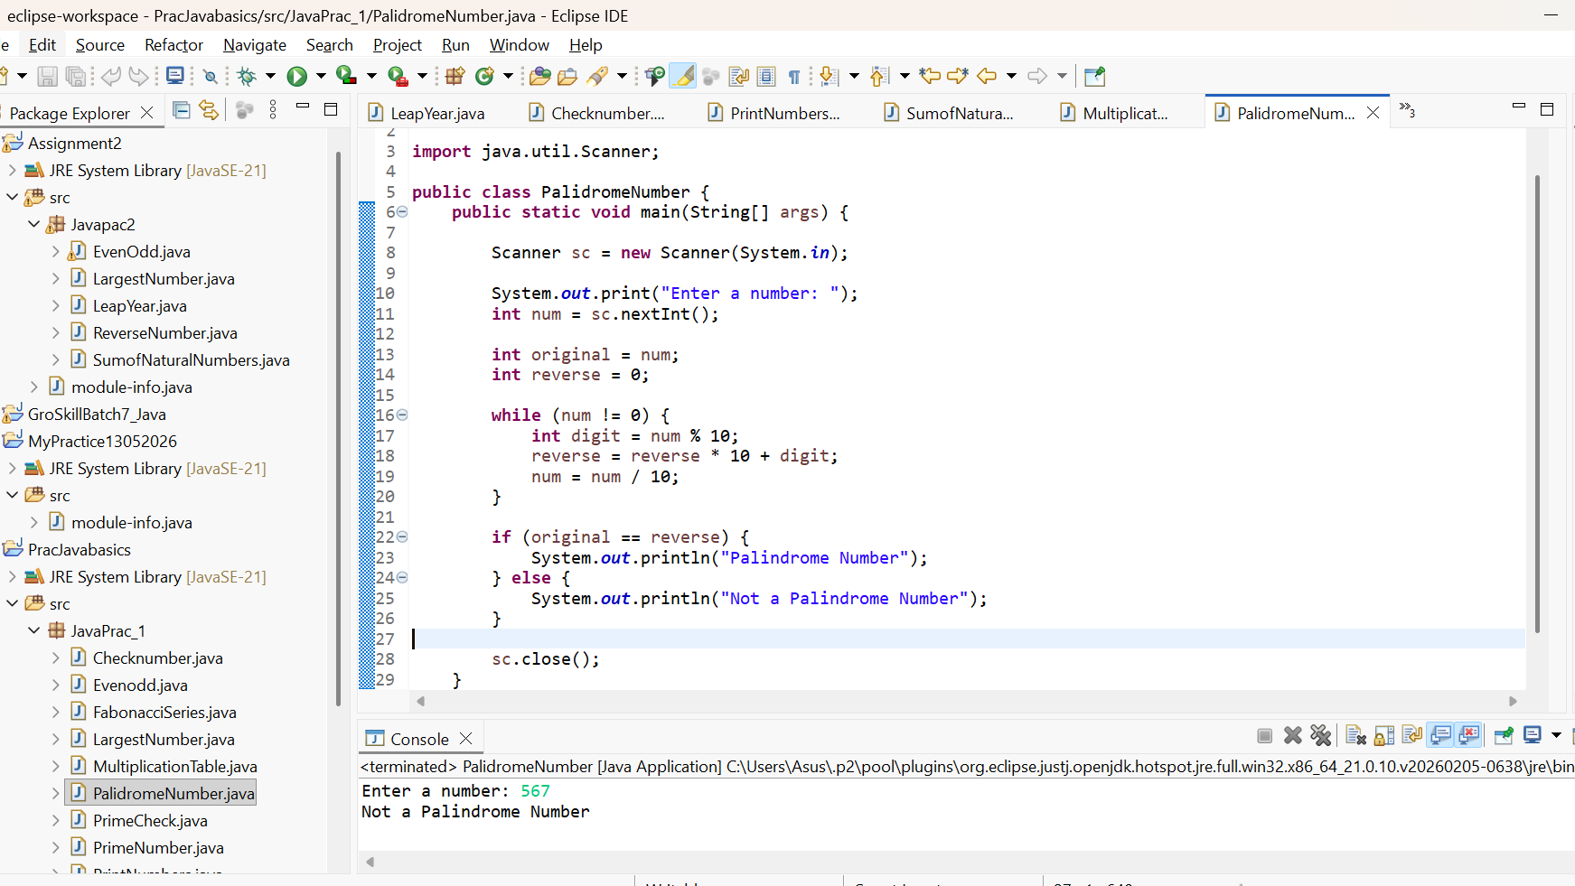

10. Count Digits in a Number
Write a program using a while loop to count the number of digits in an integer.
Example:
Input: 98765
Output: 5
Program:
package Javapac2;
import java.util.Scanner;

public class Countthedigit {

public static void main(String[] args)
{
System.out.println("Enter the number");
Scanner sc = new Scanner(System.in);

int num = sc.nextInt();
int count = 0;

while (num != 0) {
num = num / 10;
count++;
}

System.out.println(count);

sc.close();
}

Output:
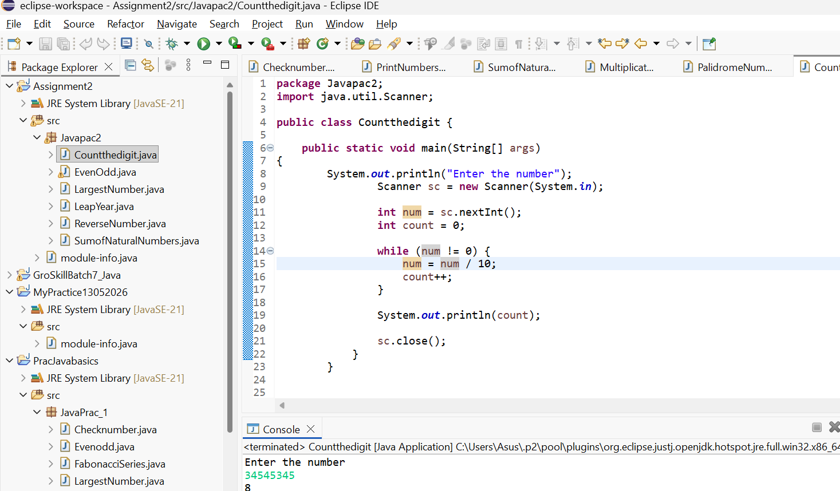

11. Factorial of a Number

Write a program using a for loop to find factorial of a number.
Example:
Input: 5
Output: 120
Program:
package Javapac2;
import java.util.Scanner;
public class Factorial {
public static void main(String[] args)
{

Scanner sc = new Scanner(System.in);

System.out.print("Enter a number: ");
int n = sc.nextInt();

long factorial = 1;

for (int i = 1; i <= n; i++) {
factorial = factorial * i;
}

System.out.println("Factorial of " + n + " = " + factorial);
}
}

Output:
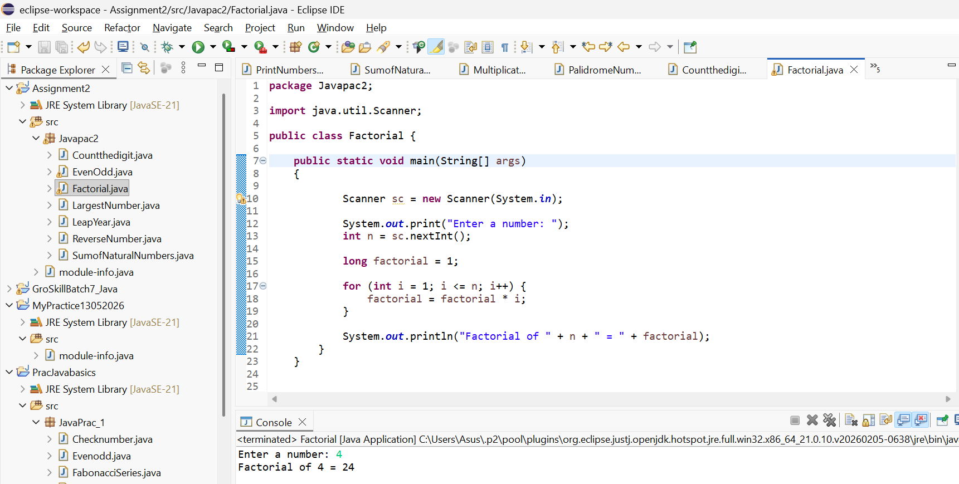

12. Prime Number Check
Write a program to check whether a number is prime or not using loops and if condition.
Example:
Input: 11
Output: Prime
Program:
package JavaPrac_1;
import java.util.Scanner;

public class PrimeNumber {
public static void main(String[] args) {
Scanner scanner = new Scanner(System.in);
System.out.print("Enter a number: ");
int number = scanner.nextInt();
if (isPrime(number)) {
System.out.println(number + " is a prime number.");
} else {
System.out.println(number + " is not a prime number.");
}
scanner.close();
}
private static boolean isPrime(int num) {
if (num <= 1) {
return false;
}
for (int i = 2; i <= Math.sqrt(num); i++) {
if (num % i == 0) {
return false;
}
}
return true;
}
}
Output:
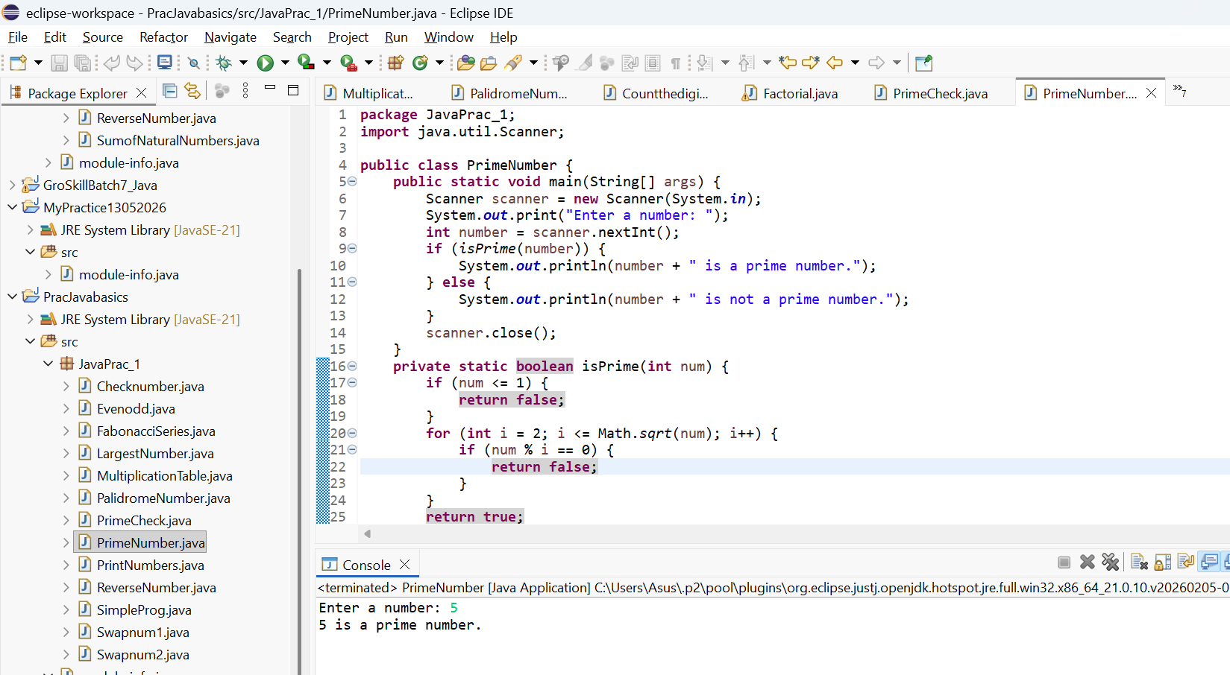
13. Fibonacci Series

Write a program to print Fibonacci series up to N terms using a loop.
Example:
Input: 6
Output: 0 1 1 2 3 5
Program:
import java.util.Scanner;

public class FabonacciSeries {
public static void main(String[] args) {

Scanner sc = new Scanner(System.in);

System.out.print("Enter number of terms: ");
int n = sc.nextInt();

int a = 0, b = 1, c;

System.out.println("Fibonacci Series:");

for (int i = 1; i <= n; i++) {
System.out.print(a + " ");

c = a + b;
a = b;
b = c;
}

sc.close();
}
}
Output:
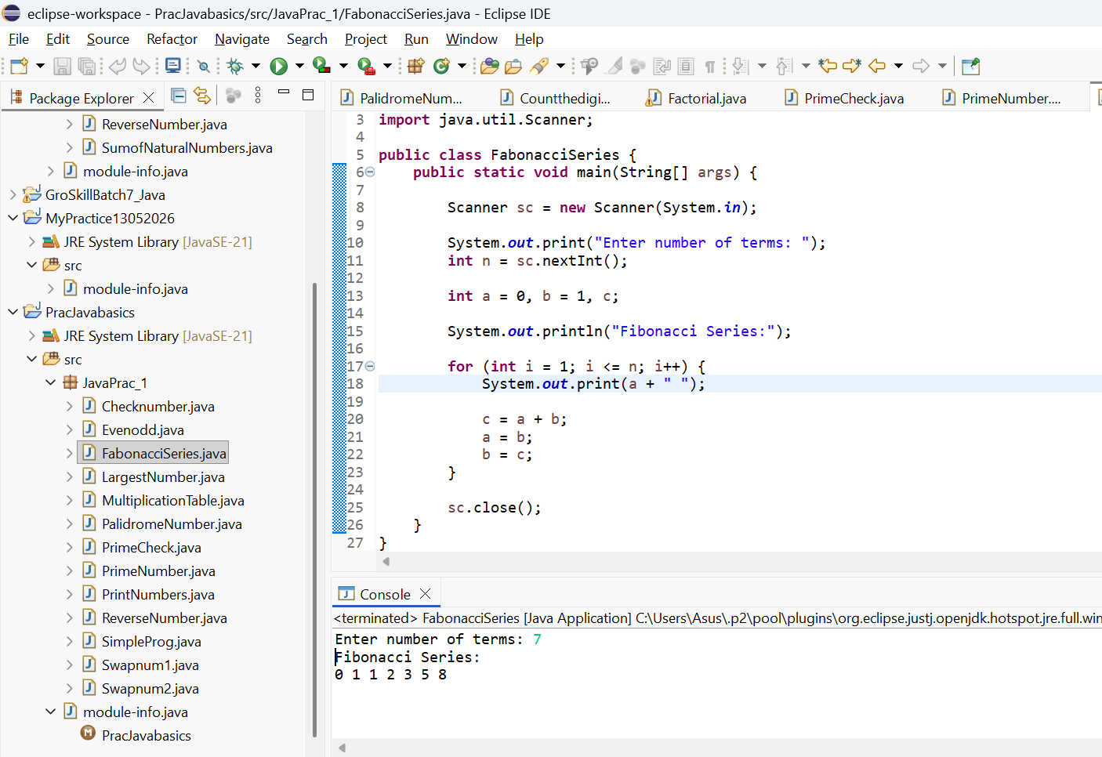

14. Menu-Driven Calculator using do-while

Create a calculator using do-while loop that repeatedly asks the user to:
Add
Subtract
Multiply
Divide
Exit
The program should continue until the user chooses Exit.

Program:
package Javapac2;
import java.util.Scanner;
public class calculator {

public static void main(String[] args) {
Scanner sc = new Scanner(System.in);

int choice;
double num1, num2, result;

do {
System.out.println("\n--- Calculator Menu ---");
System.out.println("1. Add");
System.out.println("2. Subtract");
System.out.println("3. Multiply");
System.out.println("4. Divide");
System.out.println("5. Exit");
System.out.print("Enter your choice: ");
choice = sc.nextInt();

switch (choice) {
case 1:
System.out.print("Enter first number: ");
num1 = sc.nextDouble();
System.out.print("Enter second number: ");
num2 = sc.nextDouble();
result = num1 + num2;
System.out.println("Result = " + result);
break;

case 2:
System.out.print("Enter first number: ");
num1 = sc.nextDouble();
System.out.print("Enter second number: ");
num2 = sc.nextDouble();
result = num1 - num2;
System.out.println("Result = " + result);
break;

case 3:
System.out.print("Enter first number: ");
num1 = sc.nextDouble();
System.out.print("Enter second number: ");
num2 = sc.nextDouble();
result = num1 * num2;
System.out.println("Result = " + result);
break;

case 4:
System.out.print("Enter first number: ");
num1 = sc.nextDouble();
System.out.print("Enter second number: ");
num2 = sc.nextDouble();

if (num2 != 0) {
result = num1 / num2;
System.out.println("Result = " + result);
} else {
System.out.println("Cannot divide by zero!");
}
break;

case 5:
System.out.println("Exiting Calculator...");
break;

default:
System.out.println("Invalid choice! Please try again.");
}

} while (choice != 5);

sc.close();
}

}

Output:
-- Calculator Menu ---
1. Add
2. Subtract
3. Multiply
4. Divide
5. Exit
Enter your choice: 3
Enter first number: 78
Enter second number: 2
Result = 156.0

--- Calculator Menu ---
1. Add
2. Subtract
3. Multiply
4. Divide
5. Exit
Enter your choice: 2
Enter first number: 98
Enter second number: 76
Result = 22.0

--- Calculator Menu ---
1. Add
2. Subtract
3. Multiply
4. Divide
5. Exit
Enter your choice: 1
Enter first number: 6373
Enter second number: 377
Result = 6750.0

--- Calculator Menu ---
1. Add
2. Subtract
3. Multiply
4. Divide
5. Exit
Enter your choice: 4
Enter first number: 7600
Enter second number: 2
Result = 3800.0

--- Calculator Menu ---
1. Add
2. Subtract
3. Multiply
4. Divide
5. Exit
Enter your choice: 5
Exiting Calculator...
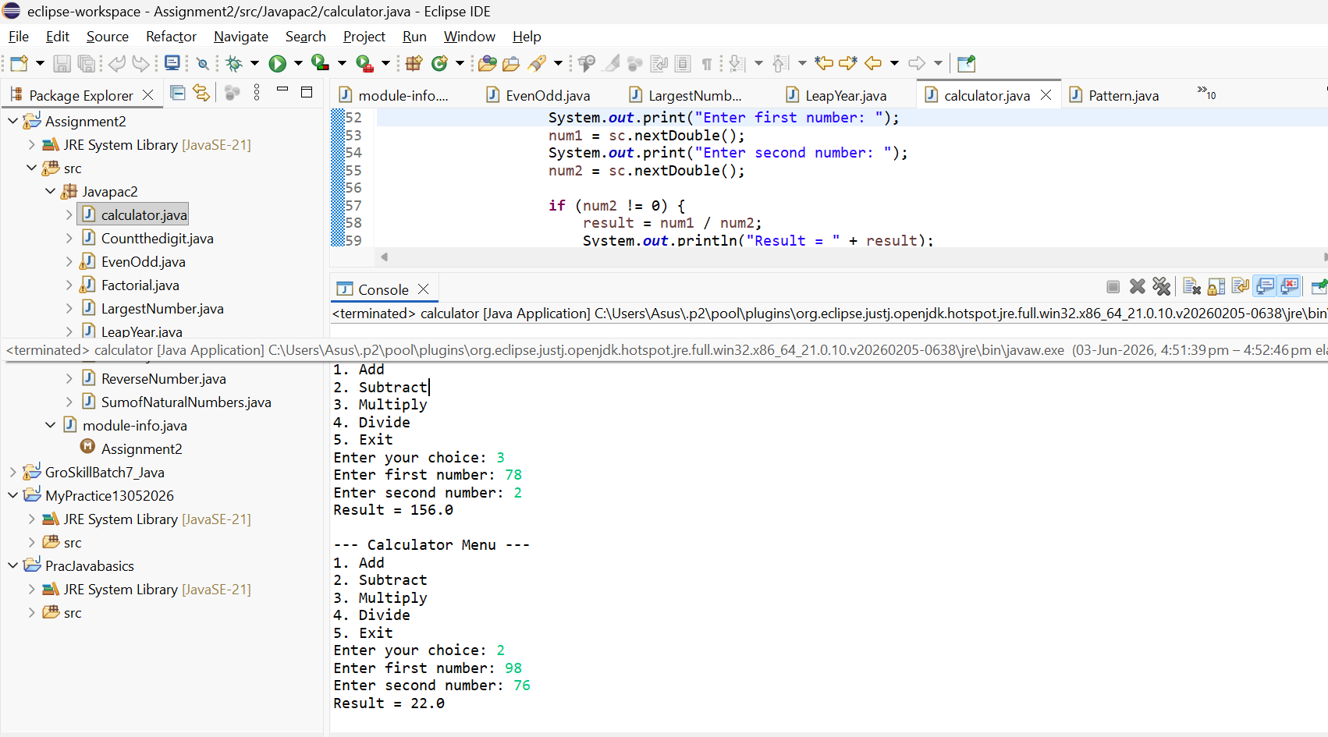

15. Pattern Printing
Write a program using nested for loops to print the following pattern:
*
**
***
****
*****
Program:
package Javapac2;
public class Pattern {
public static void main(String[] args)
{ for (int i = 1; i <= 5; i++) {
for (int j = 1; j <= i; j++) {
System.out.print("*");
}
System.out.println();}}}
Output:
